[1]

Analysis of a 2nd Order Active Band Pass Filter

Thomas Dwyer and Philip Hong

*Abstract*—In this experiment we analyzed the performance, as well as the functionality of a 2nd order active band pass filter. We specifically wanted to show how the active band pass filter still provided band pass qualities without the need of bulky and expensive inductors. Our goal for this circuit was to design a filter with a Quality factor of 5 and a resonance frequency of 4kHz. In the end our transfer plot was non symmetrical, so we ended up with two values for quality factor, our lower Q value was 5.66, and our upper Q value was 4.01. Taking the average of these two values we obtain an average Q value of 4.83 with a peak frequency of 3.85kHz; within sufficient range of our desired values.

# INTRODUCTION

A

ctive band pass filters can be decomposed into three stages, a high pass filter, an amplifier, and a low pass filter. The purpose of the amplifier is to provide isolation from these two stages as well as to define the overall voltage gain. In other words, it shapes the transfer curve and defines the quality factor of our circuit. It is important to understand the assumptions we make about these amplifiers in order to understand how we analyze these circuits. We first assume that the current flowing through the input of our op-amp is zero. This is a reasonable assumption because the input impedance of the operational amplifier, a differential amplifier followed by an equivalent current source, will be orders of magnitude greater than any input voltage we will be applying to the op amp; which means that it would be safe to assume zero current flowing through the inputs. We also assume a virtual short between the inputs, in steady state. This is because the output will always try and balance the two inputs in a closed loop feedback orientation. We can’t, however, short the two inputs; this would mean that the output will always be zero; this wouldn’t be useful because it wouldn’t be able to perform feedback properly. It is important to note that if the op amp isn’t in a closed loop feedback orientation, known as an open loop configuration, it is possible to have different voltages at the input. In this scenario, assuming that the supply rails are +- 10V, the output voltage would either be +-10V depending on the difference between the two inputs, if positive, +10V, if negative -10V will be seen at the output.

The double sided circuit board with dimensions 1x1inch cost $139.15 [3] for a lot size of two. As we increase the lot size, the price per lot decreases as can be seen by the following graph:

-Cost per Lot size graph

Bill of Materials [4]

|  |  |  |  |
| --- | --- | --- | --- |
|  | Resistor | Capacitor | OpAmp |
| Unit Cost | $0.021 | $0.09 | $0.46 |
| Amount used | 10 | 4 | 4 |
| Subtotal | $0.21 | $0.36 | $1.84 |
| Total | $2.41 | | |

As we increase our lot size the Bill of Materials Per lot size goes down as shown in the following graph:

-Bill of Materials per Lot

We can also see the same relationship in the PCB assembly cost per lot size as shown in the graph:

# System Architecture

Active filters have many advantages over their passive counterparts. For one, they don’t require bulky/ expensive inductors, making the active filter a lot smaller relative to a passive filter. Active filters also have a high input impedance as well as a low output impedance, making them a lot easier to integrate/ connect to various loads than passive filters. Active filters, however, have many downsides as well. They require DC bias/ power supply, which means they are constantly draining power. Since op-amps have a finite gain-bandwidth product the frequency operation of an active filter is limited to lower frequencies.

-Specifications [1]

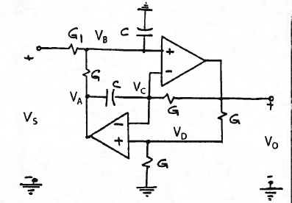

[1] This schematic must also satisfy the following parameters:

|  |  |  |
| --- | --- | --- |
| Parameter | Symbol | Value |
| Center frequency | $$f_{0}$$ | 4.0kHz |
| Quality Factor | Q | 5 |
| Capacitors | C | 10nF |
| Power Supply | VEE | ±15V |

## Design Analysis

Using Ideal Op amp equations: $V^{+}=V^{-},$ $I^{-}=I^{+}=0$

Applying nodal analysis at nodes 1 and 2:

$$Node 1:\left(\frac{V_{0}}{2}-V_{A}\right)Cs+\left(\frac{V_{0}}{2}-V_{o}\right)G=0$$

$$Node 2:\left(\frac{V_{0}}{2}-V_{s}\right)G_{1}+\left(\frac{V_{0}}{2}-V_{A}\right)G+\frac{V_{0}}{2}Cs=0$$

Eliminating $V_{A}$ with this system of equations, we arrive at the following transfer function:

$$\frac{V_{0}}{V_{s}}=\frac{\frac{2G_{1}}{C}s}{s^{2}+\frac{G_{1}}{C}s+{(\frac{G}{C})}^{2} }$$

From this we can derive the following parameters:

$\frac{w_{0}}{Q}=\frac{G_{1}}{C}$, $w_{0}=\frac{G}{C}$; since we want a Q=5, a center frequency of 4.0kHz, and since we know the value of C to be 10nF we can solve for the following values:

$R_{1}{= 1/G}_{1}≈20kohms$, $R=1/G≈ 4kohms$

This is confirmed in LTspice, setting up the circuit the same way as in the specifications and sweeping it across various frequencies, we see that it peaks at 3.97kHz and has a gain of 6db approximately 2 which is what we expect with a quality factor of 5 and a center frequency of 4kHz.

-Frequency Response (LTspice Simulation)



# Experimental Procedure

The R square term refers to the sheet resistance, which is the resistance seen across thin films of uniform thickness. In our experiment this relates to the traces/ wires that are carved out of the pcb. This is particularly useful because we can directly calculate the resistance given the dimensions of our wire.

-Layout (Eagle.brd)

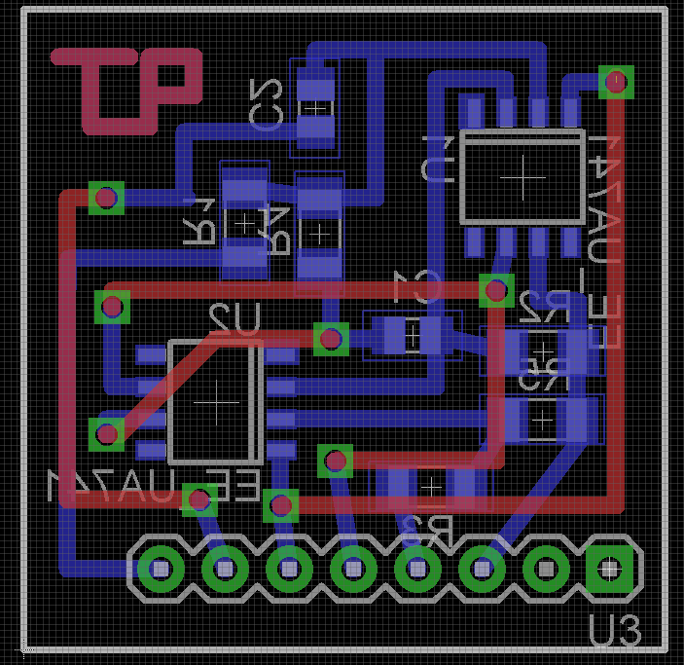

As can be seen, this layout features 5 crossovers

MLCC stands for Multi Layer Ceramic Capacitor this name comes from the many capacitors within the MLCC that are stacked in parallel. By stacking them in parallel we effectively increase the capacitance while keeping the size of the component small. The MLCC is a non polarized capacitor, meaning that it doesn’t have to be placed in a specific orientation for it to function properly, unlike the tantalum capacitors seen in lab 1.

-Procedure:

After soldering our components to the printed circuit board, we were left with the equivalent circuit:

-Schematic (Eagle.sch)

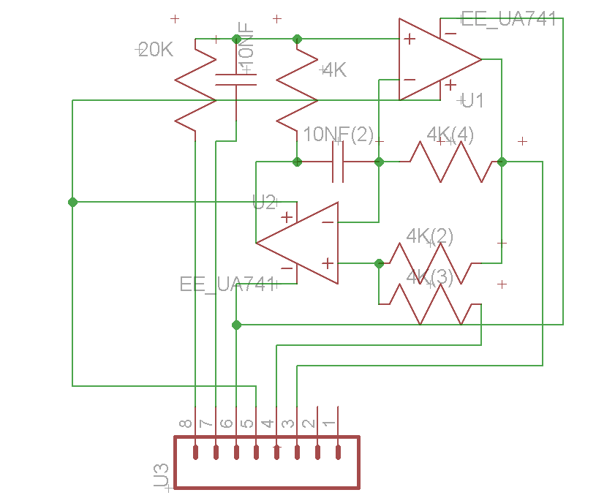

The header connections were set up as follows: Pin 8 was connected to our input, in this case the function generator, pin 7 was connected to ground, pin 6 was connected to our -15V power supply, pin 5 was connected to our +15V power supply, pint 4 was connected to ground, and pin 3 was connected to our output ( the oscilloscope). We made sure that there was a ground connection in between our input/ output and the supply voltages; to shield our signals. Once everything was connected we swept our function generator’s frequency recording the output voltage from the oscilloscope after each change in the frequency at the function generator.

# Results

Table 1. Experimental Values

|  |  |  |  |  |  |
| --- | --- | --- | --- | --- | --- |
| 1 | 0.107 | 3.7 | 1.714 | 5.9 | 0.469 |
| 1.3 | 0.144 | 3.85 | 1.908 | 6.2 | 0.428 |
| 1.6 | 0.188 | 4 | 1.836 | 6.5 | 0.387 |
| 1.9 | 0.244 | 4.2 | 1.530 | 6.8 | 0.357 |
| 2.2 | 0.312 | 4.33 | 1.346 | 7.1 | 0.326 |
| 2.5 | 0.408 | 4.5 | 1.122 |
| 2.8 | 0.540 | 4.8 | 0.877 |
| 3.1 | 0.760 | 5 | 0.755 |
| 3.4 | 1.142 | 5.3 | 0.622 |
| 3.51 | 1.346 | 5.6 | 0.530 |

Fig. 1. Experimental measurements Qlower=5.66, Qupper=4.01; effective/ Average Q=4.83

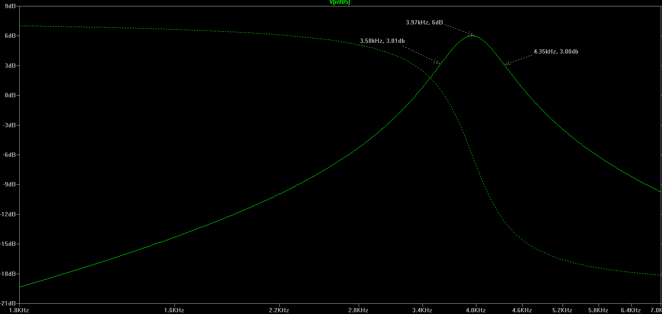

Fig. 2 Theoretical Results (LTspice Frequency Response) Q=5

TABLE II

Theory vs. Experiment

|  |  |  |  |
| --- | --- | --- | --- |
| Revised Design Target | Experimental Value | | Error |
| *Q=5 $Q_{eff}$* =4.83 3.4% $f_{0}=3.97kHz$ $f_{0}=3.85kHz$ 3.0% $f_{1}=3.58kHz$ $f_{1}=3.51kHz$ 2.0% $f_{2}=4.35kHz$ $f_{2}=4.33kHz$ 0.5% | | | |
|  |  |  | |

*Design targets modified from initial design parameters of Q=5, center freq=4kHz to LTspice simulation values

# Conclusion

Our results were in nearly perfect agreement with our expectations. All of our percent difference errors were below 5%. We can attribute such high accuracy to the simple fact that everything was provided for us. Our design analysis was limited to analyzing resistor values. Once this was done we ordered parts that met our desired values, and simply put everything together. Since there was very little variation from the design process to the physical implementation we expect our results to be in agreement if not very close.

It is important to note that our experimental values were not symmetric across the center frequency, this was our biggest departure from ideality. To compensate for this we modified our design parameters to the LTspice simulation values. We also calculated an effective Quality factor for our experimental results by taking the average of Qlower and Qupper. By doing this our results matched with our expectations better.

The difficulty in this experiment manifested itself in the soldering process. When working with such small sizes it becomes increasingly difficult to solder vias correctly, the simple task of applying solder paste to the board was hampered by the constant shakes in my hand. These factors led to the destruction of our first pcb, when we improperly soldered a via causing one of our opamps to blow up. It all added up to a huge amount of energy as well as time on our part in constructing this circuit.

References

1. H. Babaie, “Experiment 2,” in *115B Lab Manuel,* *,* City of Los Angelest
2. Hassan Babaie, (2014) ‘Week 3: Experiment, *EE115BL*.
3. "Sunstone Printed Circuit Boards | PCB Prototype & PCB Fabrication." *Sunstone Printed Circuit Boards | PCB Prototype & PCB Fabrication*. N.p., n.d. Web. 02 May 2014..
4. "Electronic Components." *Electronic Parts, Components and Suppliers*. N.p., n.d. Web. 02 May 2014..

1. This work is supported in part by the Electrical Engineering department of the University of California Los Angeles

   .